AVAILABILITY AND IRREVERSIBILITY

Available Energy:
The sources of energy can be divided into two groups namely, high-grade energy and low-grade energy. The conversion of high-grade energy to shaft work is exempt from the limitations of the second law, while conversion of low grade energy is subjected to them.
Example: High grade energy:
1) Mechanical work 2) electrical energy 3) water power 4) wind power 5) kinetic energy of a jet 6) tidal power.
Example: Low grade energy: 1) Heat or thermal energy 2) heat derived from nuclear fission or fusion. 3) Heat derived from combustion of fossil fuels. 4) Solar energy.
The high-grade energy in the form of mechanical work or electrical energy is obtained from sources of low-grade energy. The complete conversion of low-grade energy, heat in to high-grade energy, shaft work is impossible. That part of low-grade energy which is available for conversion is referred to as available energy, while the part which according to the second law must be rejected is known as unavailable energy.
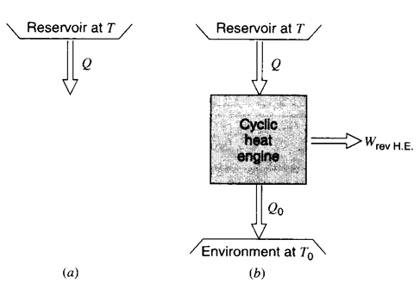

Fig 1: Heat transfer from a constant temperature energy source.

In the previous chapter the concept of efficiency of a device such as turbine, nozzle and compressor are introduced and more correctly termed as first law efficiency, since it is given as he ratio of two energy terms. This chapter gives more meaningful definition of efficiency- second law analysis. Our main goal is to use this analysis to manager our thermal resources and environment better.

Consider the simple situation shown in figure1 in which there is an energy source Q in the form of heat transfer from a very large source and therefore constant temperature reservoir at temperature T. what is the ultimate potential for producing work?

To answer to this question we imagine that a cyclic heat engine is available as shown in figure (b) to convert the maximum fraction of Q requires that the engine be completely reversible, i.e. a Carnot cycle, and that the lower temperature reservoir be at the lowest temperature possible, often but not necessarily at the ambient temperature. From the first and second laws for the Carnot cycle and the usual consideration of all the Q’s as positive quantities we find

W _{rev HE} = Q –Q_{o} Q / T = Q_{o} / T_{o}
W _{rev HE} = Q {1-( T_{o} / T ) }

The fraction of Q given by the right side of the equation is the available portion of the total energy quantity Q.

Consider the situation shown on the T-S Diagram.
The total shaded diagram is Q.
The portion of Q that is below To, the environment temperature, cannot be converted into work by the heat engine and must instead be thrown away. This portion is therefore the unavailable portion of the energy Q, and the portion lying between the two temperatures T and To is the available energy.

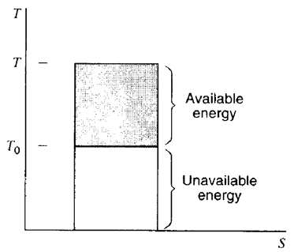

Fig 2: T-S Diagram for a constant temperature energy source.

Let us consider the same situation except that the heat transfer Q is available from a constant pressure source, for ex, a simple heat exchanger as shown in the figure. The Carnot cycle must now be replaced by a sequence of such engines, with the result shown in the figure B the only difference between the first and the second example is that the second includes an integral, which corresponds to ΔS

ΔS = ∫ (δQ _{rev} / T ) = Qo /To

W _{rev} = Q – To * ΔS
Note that this ΔS quantity does not include the standard sign convention. It corresponds to the change of entropy. The equation specifies the available portion of the quantity Q. the portion unavailable for producing work in this circumstance lies below To.

Thus the unavailable energy is the product of lowest temperature of heat rejection ands the change of entropy of the system during the process of supplying heat.
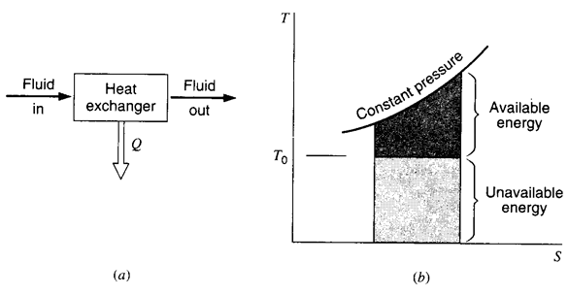

Fig 3: Changing temperature energy source.

Decrease in available energy when the heat is transferred through a finite temperature difference:

Whenever heat id transferred through a finite temperature difference there is a decrease in the availability of the energy so transferred. let us consider a reversible heat engine operating between T₁ and To as shown in the figure

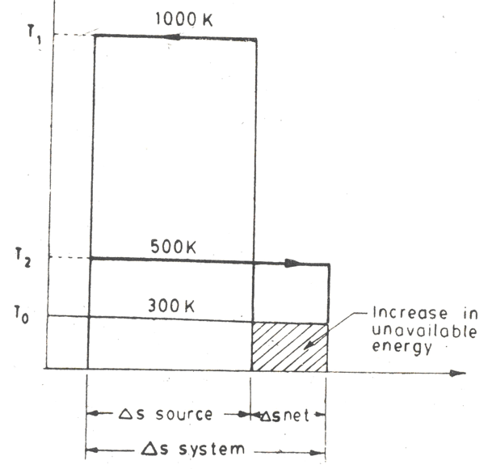

Fig 4: Increase in unavailable energy due to heat transfer through a finite temperature difference.
Then we have Q₁ = T₁ * ΔS
Q₂ = To * ΔS
W = AE = (T₁ – To) ΔS

Let us now assume that q₁ is transferred through a finite temperature difference from the reservoir or source at T₁ to the engine absorbing heat at T’₁ lower than T₁ as shown in the figure

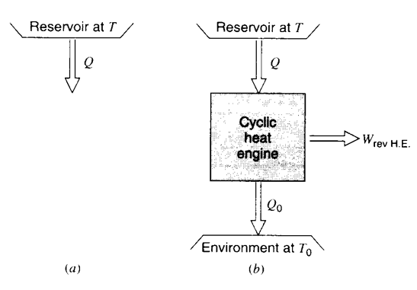

Fig 5: Constant Temperature energy source.

The availability of Q₁ as received by the engine at T’₁ and to receiving Q₁ and rejecting Q’₂.

Q₁ = T₁ ΔS = T ’₁ ΔS’
T₁ > T ’₁, Hence ΔS’ > ΔS
Q₂ = Tc ΔS and Q‘₂ = To ΔS’

Since ΔS’ > ΔS hence Q’₂ > Q₂
And hence W = Q₁- Q’₂ = T’₁ ΔS’ - To ΔS’
And W = Q₁ – Q₂ = T₁ ΔS – To ΔS
Hence W’< W since Q’₂ > Q₂.

Available energy lost due to irreversible heat transfer through finite temperature difference between source and working fluid during heat addition process is given by

W- W’ = Q’₂ - Q₂ = To (ΔS’ - ΔS)
or decrease in AE = To (ΔS’ - ΔS)

Thus the decrease in available energy is the product of the lowest feasible temperature of heat rejection and the additional entropy change in the system while receiving heat irreversibly compared to the case of reversible heat transfer from the same source. The greater is the temperature difference (T₁ – T’₁) the greater is the heat rejection Q’₂ and greater will be the unavailable part of the energy supplied. Energy is said to be degraded each time when it flows through a finite temperature difference. That’s why the second law is some times called the law of degradation of energy and the energy is said to run down hill.

Availability:

The availability of a given system is defined as the maximum useful work (total work – pdV work) that is obtainable in a process in which the system comes to equilibrium with its surroundings. Availability is thus a composite property depending on the state of the system and surroundings.

Let U,S and V be the initial energy, entropy and volume of a system and Uo So, Vo their final values when the system has come to equilibrium with its environment. The system exchanges heat only with the environment. The process may be either reversible or irreversible. The useful work obtained in the process in the form of equation

W <= (U – ToS + po V) – (Uo – ToSo _ poVo)

Let Φ = U – ToS + p_{o}V where Φ is called the availability function and a composite property of both the system and its environment, with U,S,V being properties of the system at some equilibrium state and To po are the temperature and pressure of the environment. The decrease in availability function in a process in which the system comes to equilibrium with the environment is

Φ - Φo = (U – ToS + po V) – (Uo – ToSo _ poVo)

Hence W < = Φ - Φo

Thus the useful work is equal to or less than the decrease in availability function. The availability A of a given system in a given environment is the maximum useful work obtainable in reversible process.
A = W max = Φ - Φo .

This work is obtained in part from a decrease in the internal energy of the system and in part from the heat withdrawn from the environment.

Let a system be taken from an equilibrium state 1, in which its availability is A₁ to a second equilibrium state 2 in which its availability is A₂. The end state 2 is not in equilibrium with the environment. The maximum useful work that could be obtained in the process
W max = A₁ – A₂ = (Φ₁ - Φo ) – (Φ₂ - Φo )

W max = (Φ₁ - Φ₂)

Availability in steady flow:

The steady stet steady flow equation is given by

H1 + ½ (mv₁² ) + mgz1 + Q = H2 + ½ (mv₂² ) + mgz₂ + W
The subscript 1 and 2 refer to the entrance and exit respectively. At the exit let the system be in equilibrium with the environment at pressure po and temperature To. Let symbols without subscripts refers to the entrance condition of the system and changes in KE and PE are negligible. Then useful work is given by
W = (H-Ho) + Q. the greater the value of Q larger will be the useful work. Thus W will be maximum when Q is a maximum.

Let S and So be the entropies of the systems at the entrance and exit of the device then

(ΔS) system = So – S. and (ΔS) surr = - (Q / To)
From the entropy principle ( So –S ) – (Q - To) > = 0.
Therefore Q <= To (So- S) .

The useful work W <= (H-Ho) + To(So-S)
<= (H-ToS) + (Ho - ToSo)
Hence W <= B – Bo where B = H-ToS it is called availability function for steady flow and is also called as Keenan function.

For entrance and exit condition the useful work is maximum when the heat absorbed is a maximum. I.e when the internal irreversibility is zero.

The maximum work obtainable from a system at the entrance of a device when the pressure and temperature at the exit are those of the environment is called the available of the system in steady flow and is given by
A = W max = B- Bo.
The alternative names for availability and for unavailable quantity To ΔS are Exergy and Anergy respectively.

Reversible work in a non-flow process:
In a non-flow process dm1 = dm2 =0

The entropy equation for flow process reduces to
(dW)_{rev} = - d (U₁ - ToS + ½ (mv₁² ) + mgZ)

Between two equilibrium end states 1 and 2

(W) _{rev1-2} = U₁-U₂ –To(S₁-S₂) + m( V₁²-V₂²)/2 + mg(Z₁-Z₂)

If the system doesn’t possesses any KE and PE

(W) _{rev1-2} = U₁-U₂ –To(S₁-S₂)

Irreversibility:

The actual work done by a system is always less than the idealized reversible work, and the difference between the two is called the irreversibility of the process.

I = W _{max} – W
This is also some time referred to as degradation or dissipation. For a non flow process between the equilibrium states, when the system exchanges heat only with the environment

I = {(U₁-U₂) – To(S₁-S₂) } – {(U₁-U₂) + Q} = To (S₂-S₁) – Q
= To (ΔS) system + To (ΔS)surr
= To[ (ΔS)system + (ΔS)surr ] Hence I > 0.

Similarly for the steady flow process I = W_{max} – W

= To (S₂-S₁) – Q
= To (ΔS) system + To (ΔS)surr
= To[ (ΔS)system + (ΔS)surr ]
Thus same expression for irreversibility applies to both flow and non-flow process. The quantity To[ (ΔS)system + (ΔS)surr ] represents an increase in unavailable energy or Anergy.

Second Law efficiency:

With the increased use of availability analysis in recent years a term called second law efficiency has come into more common use. This term refers to comparison of the desired output of a process with the cost or input in terms of the thermodynamic availability. Thus the isentropic turbine efficiency defined by the ratio of actual work output to the work for a hypothetical isentropic expansion. From the same inlet state to the same exit pressure which is called first law efficiency, in that it is a comparison of two energy quantities. The second law efficiency as just described would be the actual work output of the turbine divided by the decrease in availability from the same inlet state to the same exit state. Thus the second law efficiency is
η_{Second law} = W / (ψ₁ - ψ₂)

Where (ψ₁ - ψ₂) is the decrease in availability for a steady state steady flow process. Which is equal to the reversible work or maximum work obtainable.
In this sense this concept provides a rating or measure of the real process in terms of the actual change of state and is simply another convenient way of utilizing the concept of thermodynamic availability. In a similar manner the second law efficiency of a pump or a compressor is the ratio of the increase in availability to the work input to the device.

NUMERICAL EXAMPLES:

1) In a certain process a vapor while condensing at 420^{O}C transfers heat to water evaporating at 250^{O}C. The resulting steam is used in a power cycle, which rejects heat at 35^{O}C. What is the fraction of the available energy in the heat transfer from the process vapor at 420^{O}C that is lost due to irreversible heat transfer at 250^{O}C.
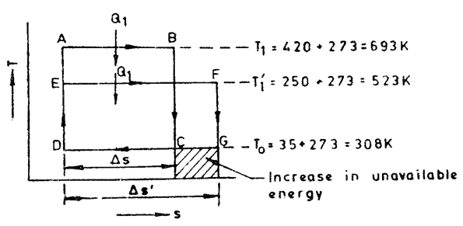

Fig 6: Increase in unavailable energy

Solution:
ABCD would have been the power cycle if there was no temperature difference between the vapor condensing and the water evaporating, and the area under CD would have been the unavailable energy at 35^{O}C. EFGD is the power cycle when the vapor condenses at 420^{O}C and the water evaporates at 250^{O}C. The unavailable energy becomes the area under DG. Therefore the increase in available energy due to irreversible heat transfer is represented by the area under CG.

Q₁= T₁ ΔS = T ’₁ ΔS’ = ΔS’ / ΔS = T₁ /T ’₁

W = work done in cycle ABCD = ( T₁- To) ΔS
W’ = work done in cycle EFGD = ( T’₁- To) ΔS’

The fraction of energy that becomes unavailable due to irreversible heat transfer

= (W-W’) / W = [ To(ΔS’-ΔS) ] / [( T₁- To) ΔS ]

= To [(ΔS’/ΔS) - 1 ] / ( T₁- To) = To( T₁- T’₁) / T₁( T₁- To)

= [308( 693-523) ] / [ 523 (693-308) ] = 0.26 Ans

2) Air expands through a turbine from 500 kPa, 520^{O}C to 100 kPa,. 300 ^{O}C. during expansion 10KJ of heat is lost to the surroundings which is at 98 kPa, 20 ^{O}C. neglecting KE and PE changes determine per kg of air a) the decrease in availability b) the maximum work c) the irreversibility.

Solution:
For air the change in entropy is given by S₂-S₁=[ mC_{p} ln (T₂/T₁) - mR ln(P₂/P₁)]

For 1kg of air s₂-s₁ = Cp ln (T₂/T₁) - R ln(P₂/P₁)
The change in availability is given by, (ψ₁ - ψ₂) = b₁-b₂ = (h₁-T_{os1}) - (h₂ –T_{os2})

= (h₁-h₂) –To (s₁-s₂) = Cp(T₁-T₂) – To (Cp ln (T₂/T₁) - R ln(P₂/P₁))

= 1.005 (520-300) – 293(1.005 ln(573/793) -0.287 ln (1/5)

= 1.005 (220) – 293 (-0.4619 + 0.3267) = 221.1 + 39.6 = 260.7 kJ/kg

W max = Change in availability = (ψ₁ - ψ₂) = 260.7 kJ/kg

From SSSF equation we have
Q + h₁ = W + h₂ or W = (h₁-h₂) + Q = 1.005(520-300) –10 =211.1 kJ/kg

Thus the irreversibility I = Wmax – W = 260.7 – 211.1 = 49.6 kJ/kg Ans.

3) Consider a steam turbine that has throttle governor. The steam in the pipeline flowing through the turbine has a pressure of 3 MPa and a temperature of 360 OC. At certain load the steam is throttled in an adiabatic process to 1.5 MPa. Calculate the availability per kg of steam before and after the process and the reversible work and irreversibility per kg of steam for this process. Assume To= 25OC po=1 bar = 0.1MPa

Solution:
The availability at the initial condition
= (h₁-h_{o}) –To(s₁-s_{o}) = (3140.9 – 104.9) – 298 (6.7844 – 0.3664 )
= 3036-1912.38 = 1123.62 kJ/kg Ans.

Similarly availability at 1.5MPa after adiabatic throttling = (h_{e}-h_{o}) – To(s_{e}-s_{o}) since in adiabatic throttling h_{e}=h_{i}=3140 kJ/kg and adiabatic Q = 0.

Therefore se from the steam table corresponding to he = 3140.9 kJ/kg and 1.5MPa = 7.0833 kJ/kg K.
Thus ψ_{e} = (3140.9 – 104.9) – 298 (7.0833-0.3664) = 3036.13 –2001.46 = 1034.67 kJ/kg

Hence W rev = ψ_{i} - ψ_{e} = 1123.62 – 1034.67 = 88.95 kJ/kg

Also irreversibility I= To –(s_{e}-s_{i}) = 298(7.0833-6.7844) = 89.07 as W actual is zero.

4) Consider an air compressor that receives ambient air at 100 kPa, 25OC. It compresses the air to a pressure of 1 MPa, where it exits at a temperature of 540 OK. Since the sir and the compressor housing are hotter than ambient it looses 50 kJ per kg air flowing through the compressor. Find the reversible work, reversible heat transfer and irreversibility in the process.

-Q

-W

e
i

Fig 7

Solution:
It is a non-adiabatic compression with no change in KE and PE. Using SSSF equation, which has single inlet and exit. From the ideal gas tables h₁= 298.62 kJ/kg and h_{e} = 544.69 kJ/kg, si = 6.8629 kJ/kgK and se = 7.4664 kJ/kgK.
The energy equation for the actual compressor is

W= h₁-h₂ + Q = 298.62 –544.69 –50 = -296.07 kJ/kg

The reversible work for the given change of state is given by

W rev = To (s₂-s₁) - (h₂-h₁) + Q[1-(To/T_{h})]
= 298.2 (7.4664 - 6.8629) – (0.287 ln 10)- (544.69-298.62) +0 = -263.17 kJ/kg

Thus irreversibility I =w rev-w = -263.17 – (-296.07) = 32.9 kJ/kg.
5) In a steam boiler, hot gases from a fire transfer heat to water which vaporizes at constant temperature. In a certain case, the gases are cooled from 1100ºC to 550ºC. The specific heat of gases is 1.005kJ/kg K and the latent heat of water at 220ºC is 1858.5kJ/kg. All the heat transferred from the gases goes to the water. How much does the total entropy of the combined system of gas and water increase a result of the reversible heat transfer? Obtain the result on the basis of 1 kg of water evaporated. If the temperature of the surroundings is 30ºC, find the increase in unavailable energy due to irreversible heat transfer.

Solution.
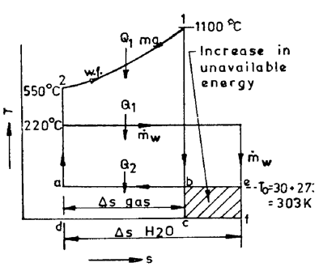

Fig 8 : h – s diagram

Gas is cooled from state 1 to state 2 (Fig). For reversible heat transfer, the working fluid in the heat engine would have been heated along 2-1, so that at any instant, the temperature difference between gas and the working fluid is zero. Then 1-b would have been the expansion of the working fluid down to the lowest possible temperature To, and the amount of heat rejection would have been given by the area abcd.

When water evaporates at 220^{.o} C as the gas gets cooled from 1100ºC to 550 ºC, the resulting power cycle has an unavailable energy represented by the area aefd. The increase in unavailable energy due to irreversible heat transfer is thus given by area befc.

(ΔS) _{water} = Latent heat absorbed /T = 1858.5/(273+220) = 3.77 kJ/kg-K
Q₁ = Heat transferred from the gas
=Heat absorbed by water during evaporation
=mgCpg (1100-550) =1 X 1858.5 kJ

Hence, m_{g}C_{pg} = 1858.5/550 =3.38kJ/º C

ΔS _{gas} = ∫ ( dQ /T ) = ∫ mg Cpg dT/T

m_{g} Cpg ln Tg₂ /Tg₁ = 3.38 ln 823 / 1373 = -3.38 * 0.51 = -1.725 kJ/K
hence ΔS total = (ΔS) _{water} + (ΔS) _{gas}
= 3.77 – 1.725 = 2.045 kJ/K
Increase in unavailable energy = To (ΔS) total = 303 * 2.045 = 620 kJ.

6) Calculate the available energy in 40 kg of water at 75ºC with respect to the surroundings at 5ºC, the pressure of water being 1 atm.

Solution:
If the water is cooled at a constant pressure of 1 atm from 75ºCto 5ºC the heat given up may be used as a source for a series of Carnot engines each using the surroundings as a sink. It is assumed that the amount of energy received by any engine is small relative to that in the source and the temperature of the source does not change while heat is being exchanged with the engine.

Let us consider that the source has fallen to temperature T, at which level there operates a Carnot engine which takes in heat at this temperature and rejects heat at To = 278 K. If s is the entropy change of water, the work obtainable is

δ W = - m (T-T_{o} ) δs where δs is negative.

δ W – 40 (T-To) Cp δ T/T = -40Cp (1-To/T) δT
With a very great number of engines in the series the total work (Maximum) obtainable when the water is cooled from 348K to 278 K would be

W (max) = AE = - lim Σ 40 Cp (1- To/T) δT
= - ∫ 40 Cp (1- To/T) δT = 40 Cp [(348-278) – 278 ln 348/278]
= 1340 kJ.
Q1 = - 4 0 * 4.2 (348-278) = 11760 kJ.

Unavailable energy = Q₁ – W _{max} = 11760 – 1340 = 10420 kJ.
7) A 5 kg copper block at a temperature of 200 ºC is dropped into an insulated tank containing 100 kg oil at a temperature of 30 ºC. Find the increase in entropy of the universe due to this process when copper block and the oil reach thermal equilibrium. Assume that the specific heats of copper and oil are respectively 0.4 kJ/kgK and 2.1 kJ /kgK.

Solution
Applying energy balance, Energy lost by copper block = Energy gained by the oil.
M_{cu} X C_{p} _{cu} X Temperature difference = m _{oil} X C_{pw} X Temperature difference.
5 X 0.4 X (200 – t ) = 100 X 2.1 (t – 30 ) 212t = 6700 , t = 31.6ºC

Heat lost by Copper = 5 X 0.4 X (473 – 304.6) = 336 8 kJ, then associated entropy change is dQ/T 336.8/473 0.7120 kJ/K.

Heat gained by oil = 100 X 2.1 X 1.6 = 1.1089 kJ/K.

Entropy of the universe = ΔS cu +ΔSoil = 0.712 +1.1089 = 1.8209 kJ/kg Ans

8) 0.5 kg of ice block at –10ºC is brought into contact with 5 kg copper block at 80ºC in an insulated container. Determine the change in entropy of

- Ice block.
- Copper block.
- The universe.

Given specific heat of ice=2kJ / kg K, specific heat of water = 4.2 kJ/kg K. specific heat of copper =0.5 kJ /kg K, enthalpy of fusion of water at 0ºC= 334 kJ/kg.

Solution
Writing the energy balance equation for the system
Energy lost by the copper block = Energy gained by the ice
5 X 0.5 (80 - t) = 0.5 X 2.0 ( 0+10) + 0.5 X 334 + 0.5 X .4.2 (t - 0)

Therefore the value of t is t = 5^{O}C

Entropy change of copper block = dQ/T = 187.5/(273 +80) = 0.53116kJ/K
Entropy change of ice block= dQ/T = (10 +167+10.5)/263 = 0.7129kJ/K

Entropy change of the universe = (Δ S )Cu + (Δ S)w = 1.24406 Ans

9) Calculate the availability and unavailability of a system that absorbs 15000kJ of heat from a heat source at 500K temperatures while the environment is at 290 K temperature.

Solution:
Entropy Change, ds = Q/T=15000/500 =30 kJ/K

Unavailable work =T _{o} ds =290 X 30 =8700 kJ
Available work = Q - T_{o} ds =15000 –290 X 30 =6300 kJ

10) 0.2 kg of air initially at 575 K temperature receives 300 kJ of heart reversibly at constant pressure. Determine the available and unavailable energies of the heat added.
Take Cp for air = 1.005 kJ / kg K and temperature of surroundings 300 K.

Solution:
Let T₂ be the temperature of air after the addition of heat at constant pressure. Then
300 = mC_{p} (T₂-T₁) = 0.2 X 1.005 (T₂ –557)
=0.201 T₂ -115.57
T₂ = (300+115.57)/0.201 =2067.5K

Entropy change, ds = mC_{p} log_{e} T₂/T₁ = 0.2 X 1.005 og_{e} 2067.5/575 = 0.2572 kJ /K
Unavailable work = T _{o} dS = 300 X 0.2572 = 77.16 kJ
Available work = Q- T _{o} dS = 300-300 X 0.2572 = 222.84 kJ

11) A closed system contains 2 kg of air during an adiabatic expansion process there occurs a change in its pressure from 500kPa to 100 kPa and in its temperature from 350 K to 320 K. if the volume doubles during the process make calculations for maximum work, the change in availability and irreversibility. Take for air C_{v} = 0.718 kJ/kg K and R = 0.287 kJ/kgK. The surrounding conditions may be assumed to be 100 kPa and 300 K.

Solution:
When the system undergoes a change from state 1 to 2 during a mass flow process the maximum obtainable work is given by

W max = (U₁-U₂) –To(S₁-S₂). Now (U₁-U₂) =

mCv(T₁-T₂) = * 0.7185(350-220) = 43.08 kJ.

And S₁-S₂ = m[Cv ln(T₂/T₁) – R ln V₂/V₁]
= 2*[0.718 l n 320 / 350 – 0.287 ln 2]
= 0.2693 kJ/K. then W max = 43.08 – 300 (-0.2693) = 123.87 kJ.
Change in availability is given by A₁ – A₂ = (U₁-U₂) –To(S₁-S₂) + Po (V₁-V₂)

V₁ = mRT₁ / P₁ = 2 * 0.287 * 250 / 500. = 0.4018 m³.
V₂ = 2 V₁ = 2* 0.4018 + 0.8036 m³.
A₁-A₂ = 123.87 + 100(0.4018 – 0.8036) = 83.67 kJ
It is the measure of maximum useful work or net work obtainable from the system.
Irreversibility = max work – actual work
W actual = Q – (U₂-U₁)

Since the system – process is adiabatic Q = 0 and W actual = -(U₂-U)₁ = U₁-U₂
= n mCv(T₁-T₂) = 2* 0.718 (350-320) = 43.08 kJ.

Irreversibility = 123.87 - 43.08 = 80.79 kJ.

Problem from Availability.

12) A system at 500 K receives 7200kJ/min from a source at 1000 K. The temperature of atmosphere is 300 K. assuming that the temperature of the system and source remain constant during heat transfer find out
The entropy produced during heat transfer.
The decrease in available energy after heat transfer.

Temperature of the source T₁ = 1000 K
Temperature of the system, T₂ = 500 K
Temperature of atmosphere, To = 300 K
Heat received by the system, Q =7200kJ/min

Change in entropy of the source during heat transfer
= -Q/T₁ = -7200/1000 = - 7.2 kJ/min K

Change in entropy of the system during heat transfer
= Q/T2 = -7200/500 =14.4kJ/min K

The net change of entropy, ΔS -7.2 + 14.4 = 7.2kJ/min K

Decrease in available energy with source = (1000-300) 7.2 = 5040kJ/min
Decrease in available energy with the system = (500 –300) 14.4 = 2880 kJ/min.

13) 15 kg of water is heated in an insulated tank by a churning process from 300 K to 340 K. If the surrounding temperature is 300 K, find the loss in availability for the process
Solution
Work added during churning = increase in enthalpy of water
= 15* 4.187*(340 300) = 2512.2 kJ = Enthalpy in the water
Availability of this energy is given by
m[(u₁-u₀) – T₀ Δs]

Δs= C_{p} log_{e} (T₁/T₀)

Δs = 4.187 log_{e} (340/300 )

Δs= 0.524 kJ/kgK
Available energy = m[Cv (T₁ – T₀)- T₀ Δs]
=15[4.187 (340 – 300) – 300 X0.524]
= 2349.3kJ Ans
Loss of availability 2512.2 – 158.7
= 2353.5 kJ Ans
This shows that conversion of work into heat is highly irreversible process, since out of 2512.5 kJ of work energy supplied to increase the temperature, only 158.7 kJ will be available again for conversion into work.

14) 5.0 kg of air at 550 K and 4 bar is enclosed in a closed system.
Determine,

i) The availability of the system if the surrounding pressure and temperature are 1 bar and 290 K respectively.
ii) If the air is cooled at constant pressure to the atmospheric temperature, find availability and effectiveness.
Availability of the system is
= m[(u₁ –u₀)-T₀(s₁-s₂)] = m[C_{v}(T₁ – T₀) - T₀Δs]

Δs = C_{p *}log_{e} (T₁/T₀) – R log_{e} (p₁/p₀)
Δs = 1.005 * log_{e}(550/290) – 0.287 * log_{e}(4/1)
= 0.643 – 0.397 = 0.246 kJ/kg K

Availability of the system = m[C_{v}(T₁ – T₀) - T₀Δs]
5[0.718(550 - 290) –290 X0.246] = 576.7 kJ Ans
ii) Heat transferred during cooling

Q = m X C_{p} X (T₁ –T₀)
5.0 X1.005 X(550 - 290) = 1306.5 kJ Heat lost by the system
Change of entropy of the system during cooling
ΔS = m X C_{p} X log_{e}(T₁/T₀)
ΔS = 5.0 X1005 X log_{e}(550/290) = 3.216 kJ/K
Unavailable portion of this energy = T₀ (Δ)S = 290 X 3.216 = 932.64 kJ
Available energy = 1306.5 - 932.64 = 373.86 kJ Ans
Effectiveness, ε = Available Energy/ Availability of the system
=(373.86/576.7) = 0.648 OR 64.8%
ε = 64.8% Ans

